1. Problem:
On the Linux server of telecommunication system, payload is send and received with high performance fast path in the Linux kernel such as PF_RING or other kernel forward technologies.
Usually these fast path utilize Mmap technology to shared memory in kernel an userspace.
When receive a packet, put the payload to a shared memory. After the userspace process the packet, the kernel will copy the packet from the shared memory to a new skb and send it.
We can see that the method of sending packet is so bad performance for copying reason. It is maybe much worst when the packet length is longer than MTU. The function ip_fragment will copy the big packet to a few small packets.

2. Opportunity:
Scatter-Gather I/O
In the case of network drivers, (non-linear) data can be scattered across page size fragments:
struct skb_frag_struct {
struct page *page;
__u32 page_offset;
__u32 size;
};
sk_buff (well, skb_shared_info) is designed to be able to hold a 64k frame in page size[1] fragments (skb_shinfo::nr_frags and skb_shinfo::frags). The NETIF_F_SG feature flag lets the core networking stack know that the driver supports scatter-gather across this paged data. Each payload can be stored in skb_shinfo(skb)->frags. This structure can be used to increase the size of the buffer by adding memory areas that can be located anywhere, so we can use the shared memory directly. The nr_frags field helps the IP layer remember how many Scatter/Gather I/O buffers hang off of this packet.

3. The solution
Firstly we use the scatter/gather I/O to avoid the memory copy from shared memory and skb linear space. We can see the difference of non scatter/gather I/O(a) and scatter/gather I/O(b).
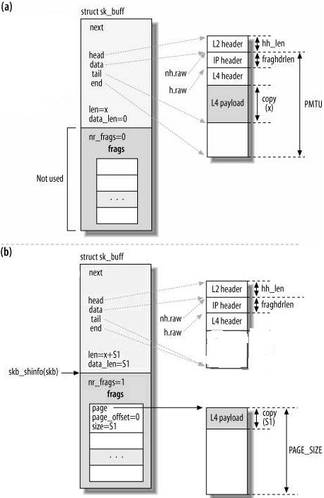

Secondly, Scatter/Gather I/O is independent from IP data fragmentation. Scatter/Gather I/O simply allows the code and hardware to work on nonadjacent memory areas as if they were adjacent. Nevertheless, each fragment must still respect the limit on its maximum size (the PMTU). Note also that the same page can hold fragments of data for different IP fragments, as shown in following. We make the payload to a list for skb and send it in ip_fragment without memcpy.
